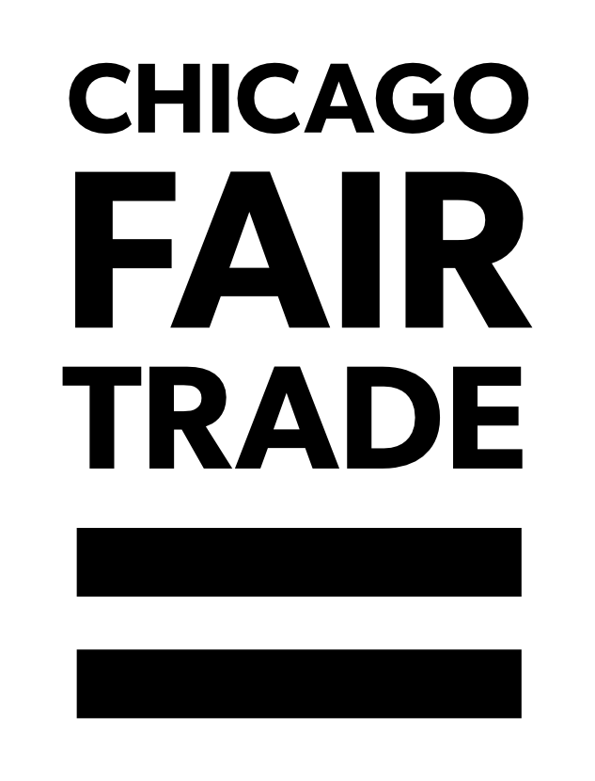
Business Membership Application Form

ELIGIBILITY CRITERIA
- Organizations (for-profits or not-for-profits) that produce, import, and/or sell products that alleviate income inequality.
- Products can be either fairly traded (see FTF and WFTO definitions of fair trade) from other countries or produced locally by social enterprises.
- An ongoing, permanent presence in the Chicagoland area such as an office, warehouse, distribution center, or established sales rep who will participate in CFT events on a regular basis.
Note: Congregations, educational institutions, non-profit organizations not selling merchandise, or municipalities can request their applications here.

WHO WE ARE
Chicago Fair Trade (CFT) is the largest fair trade coalition in the USA, comprised of a dedicated base of member businesses, educational institutions, congregations, non-profit organizations, and individual activists. CFT increases support for economic & environmental justice through consumer education, advocacy, and promotion of local fair trade businesses. CFT is committed to growing a thriving fair trade community in the Chicagoland area. The more you put in, the more you get out.

CFT MEMBERSHIP BENEFITS:
- Exposure to new customers, allies, and businesses in the Chicagoland area.
- Exposure on the CFT website, social media platforms, and the media.
- Use of the CFT logo on product literature, business cards, banners, and displays.
- Network of mentorship and support as you build and grow your business.
- Fair Trade sales opportunities at CFT events including World Fair Trade Day, Fashion Revolution, Globalfest, and the Holiday Pop-Up Shop.
- A sense of community – Connects you with others who are passionate about fair trade at the local and national level.

CFT MEMBER EXPECTATIONS:
- Collaborate with CFT membership to support each other and share best practices.
- Grow conscious consumers in the Chicagoland area.
- Include a page about fair trade on your website, the CFT logo, and a link to our webpage.
- Be current on annual dues for participation in membership benefits.
- Promote CFT’s mission by attending CFT events, serving on committees, becoming a board member, or volunteering at events.

APPLICATION DEADLINES
We accept applications throughout the year. Applications are reviewed quarterly. Decisions are made within 30 business days of each deadline.
- March 15th (Deadline for participating in World Fair Trade Day events).
- June 15th
- September 15th (Deadline for participating in Holiday Pop-up Shop).
- December 15th

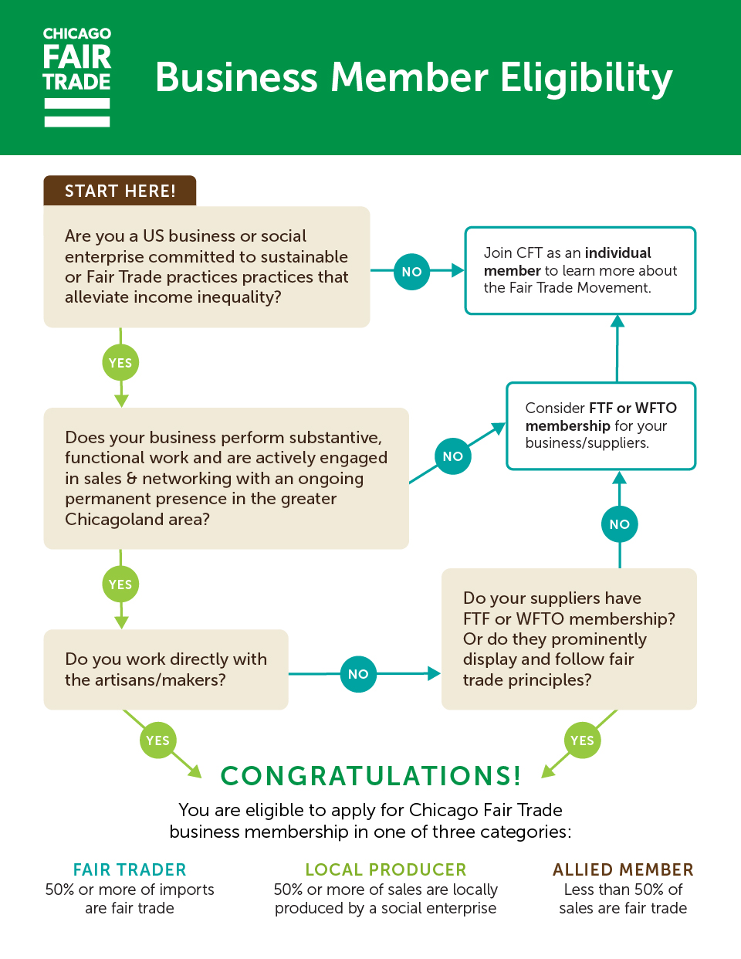
AS YOU FILL OUT THIS APPLICATION, PLEASE BE THOUGHTFUL AND THOROUGH IN YOUR RESPONSE TO EACH QUESTION. LEAVING QUESTIONS BLANK OR INCOMPLETE MAY DELAY YOUR APPLICATION.

PART 1: CONTACT INFORMATION

Name of Business: Website:

DBA Name of Business:

Contact Name: Contact Title:

Email: Cel/Tel:

Business Address (Include City, State, Zip):

Warehouse Address (if different than above):

Business Phone Number (public number):

Federal Tax ID Number: State Sales Tax ID Number:

Business Membership Category (What type of membership are you applying for?):
Fair Trader: 50% or more of sales are fair trade.
Local Producer: 50% or more of sales are locally produced by a social enterprise.
Allied Member: Less than 50% of sales are fair trade

How did you learn about Chicago Fair Trade?

PART 2: TELL US ABOUT YOUR BUSINESS

2.1 How many years have you been in business?

2.2 How does your business relate to fair trade?

2.3 What is your mission statement?

2.4 Are you a for-profit or not-for-profit business?

2.5 How much did your business earn in gross sales in the last fiscal year?
Less than $100,000
$100,000 to $299,999
$300,000 to $499,999
$500,000 to $999,999
$1,000,000 to $4,999,999
$5,000,000 to $9,999,999
$10,000,000 or more

2.6 What is the your expected annual operating budget for the current year?

2.7 Please list and explain the fairly-traded products you currently carry. Include links to website or social media sites that have photos of your products.

2.8 What percentage of your items are fair trade or from local social enterprises?
What percent of your items are not fair trade and list or describe them?

2.9 Are you currently a member of either the Fair Trade Federation (FTF) or the World Fair Trade Organization (WFTO)? If yes, which organizations? If neither, do you have plans to do so in the future?

2.10 Please provide us with a one paragraph description of what you would like on our website if you are approved.

2.11 What is your long-term vision? Is this your full-time job?

2.12 How many people do you impact per country? For each country you source from, please estimate how many people are directly impacted by your purchases.

2.13 What is your annual Cost of Goods per country? If possible, please report total costs from your last fiscal year.

PART 3: TELL US ABOUT YOUR FAIR TRADE PRACTICES
The principles of fair trade are described by the Fair Trade Federation (FTF) and the World Fair Trade Organization (WFTO). Please read about fair trade in the links provided. As you answer the questions in Part 3, please reflect on how your company does or does not follow the fair trade principles. Note: Please be as detailed as possible. Leaving questions blank or incomplete may delay your application.

3.1 Name your suppliers and the countries you source from.

3.2 How do you empower artisans, farmers and other producers (particularly women) for their contributions to production and trade?

3.3 Do you pay a living wage to artisans or farmers that provide you with products? If yes, what is that wage and how do you determine it? You may use the fair trade calculator as a resource: https://www.fairwageguide.org/

3.4 What is your relationship with the artisans or farmers from whom you source?

3.5 How does your business respect and nurture the cultural identity of farmers, artisans or producers with whom you trade?

3.6 Do you pay a living wage to your employees in the U.S.? If yes, what is your living wage? (a range is ok)

3.7 How do you promote and participate in environmentally-sustainable practices both here and abroad?

3.8 What do you know about the supply chain of the raw materials used by your producers?

3.9 Please share any improvements you have made in your supply chain or plans you have in place to improve your sourcing moving forward?

3.10 If accepted into CFT, do you commit to educate yourself more about your industry via articles, books, networking opportunities and/or conferences?
(yes or no)

Chicago Fair Trade and the fair trade movement as a whole are constantly evolving, and striving to learn more and do better. As we learn more about exploitation within jewelry supply chains, it is imperative that our members who create jewelry fully understand their supply chains, where raw materials come from, or at the very least are advancing in their fair trade journey by educating themselves and making plans for improvement.
Thus, if you sell jewelry, please answer questions 3.11 – 3.13

3.11 Please provide information about where you or your artisans source your silver or gold.

3.12 Please provide information about where you or your artisans source your gemstones. Where do your gemstones come from?

3.13 Please provide information about where your gems are cut.

PART 4: TELL US ABOUT YOUR CONNECTIONS TO CHICAGO.

4.1 Why would you like to become a Chicago Fair Trade Member?

4.2 What ties does your business have in the Chicagoland area?

4.3 Have you participated in any events in the Chicagoland area? If so, please name.

4.4 How would you promote and expand the footprint of CFT in the Chicagoland area?

4.5 What skills/resources/knowledge would you be willing to share with fellow CFT businesses?

4.6 How would you work with Chicago Fair Trade in it’s missions to advocate fair trade policy initiatives, educate and promote fair trade to others, and implement living wage standards for businesses? There is a range of different ways CFT business members can be involved and contribute to our mission. Check all that apply.
Volunteer at events
Participate in fundraising activities
Special event planning
Help develop workshops for members
Help develop workshops for the public and/or the public
Public Speaking on Fair Trade
Fair Trade in the Sanctuary
Participate in Sales events
Donate items to silent auction
Other:

4.7 How would you participate in CFT events?

4.8 If accepted, what do you expect to get out of your CFT Membership?

4.9 Is there anything else you would like to share with us about your business?

Submit your completed application to membership@chicagofairtrade.org
All applications will be reviewed by the membership committee within 30 business days from each deadline described above.

If accepted, payment of dues is due upon approval of your application. If not paid within 30 days, membership will start the following quarter.

Dues are renewed annually and must be paid within 30 days of invoice. Otherwise, a $50 late fee will be applied. If membership lapses for 6 months, then you need to re-apply. Please note, we are mostly an all-volunteer organization (one full time staff) and don’t always have the time to follow-up. It is the job of the business member to pay promptly.

Address checks to: Chicago Fair Trade, 637 S. Dearborn St., 3rd Floor, Chicago, IL 60605. Or make payment via PayPal using the donate button on our home page: chicagofairtrade.org.

